the EBC and the CBC differences:

Structure:

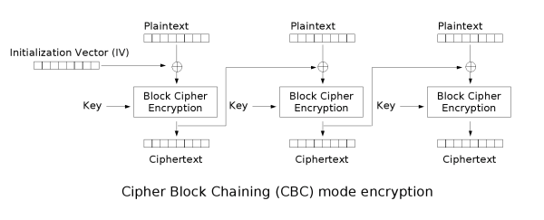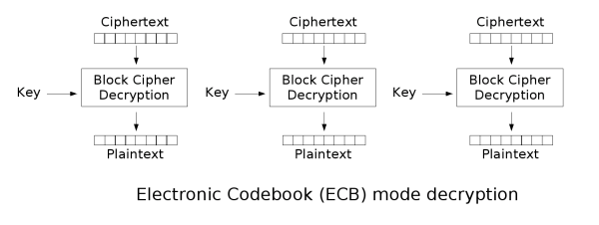

ECB

Advantages, disadvantages and process:

**Process**:

The encryption process involves dividing plaintext into fixed-size blocks, each encrypted independently using the same key, resulting in identical ciphertext blocks.

**Advantages**:

The implementation is straightforward and simple, allowing for parallel encryption and decryption of blocks.

**Disadvantages**:

This encryption method is susceptible to patterns in plaintext, deterministic encryption, and lacks diffusion, making it susceptible to the same plaintext block encrypting to the same ciphertext block.

CBC:

**Process**:

The encryption process uses an Initialization Vector (IV) and XOR operations to chain blocks together, ensuring diffusion as changes in plaintext affect subsequent blocks.

**Advantages:**

The system offers superior security compared to ECB due to diffusion and chaining, and generates unique ciphertext blocks even for identical plaintext blocks through chaining and IV.

**Disadvantages:**

The system necessitates an unpredictable IV for security, and its sequential dependency makes parallel processing more challenging than the ECB.

Comparison:

|  |  |  |  |
| --- | --- | --- | --- |
| Feature | ECB Mode | CBC Mode |  |
| Security | Less secure | More secure |  |
| Encryption Speed | Faster (potentially) | Slower |  |
| Decryption Speed | Same as Encryption | Same as Encryption |  |
| Parallelization | Possible | Not ideal |  |
| Padding Required | No | Yes |  |

**I pick CBC** Because of chaining and IV, the system generates distinct ciphertext blocks even for identical plaintext blocks, providing greater security than ECB.

frequently utilized in applications like VPNs and secure communication methods that demand more security. And the speed of the ECB Is not be so useful for the pic encryption as the security point that's why the CBC is great choice.

By the output you can see that the EBC as same as the plaintext but CBC in not.

The output:



EBC mode output



CBC mode output